LAB 1: REQUIREMENTS ENGINEERING & UML USE-CASE MODELLING
Problem Statement #49 — Webhook Ingestion & Retry Mechanism Hub
Developer Tools & IT Operations

Name: B M Harshith Kumar
Section: 5 F AI & ML
SRN: PES1UG24AM349

1. Problem Context
A resilient webhook gateway receiving third-party events, logging request payloads, delivering to internal services, and managing dead-letter queues with exponential backoff retries.
Target Stakeholders / Actors: Integration Developer, System Operator

2. Requirements Table

Req ID | Type | Description | Priority | Acceptance Criteria | Rationale
FR-001 | Functional | The system shall ingest inbound webhooks, log their payloads, and forward them to the configured target endpoint. | High | Pass: A valid webhook is received, logged, and delivered to the configured endpoint. Fail: The webhook is dropped or not logged. | Core purpose of the gateway.
FR-002 | Functional | The system shall automatically retry failed webhook deliveries using exponential backoff intervals of 1s, 2s, 4s, and 8s. | High | Pass: A failed delivery is retried at the specified intervals. Fail: The system does not retry or uses incorrect retry intervals. | Ensures resilience against temporary service failures.
FR-003 | Functional | The system shall store a webhook in a dead-letter queue when all configured delivery attempts fail. | High | Pass: After the final failed attempt, the webhook payload and failure information appear in the dead-letter queue. Fail: The failed webhook is lost. | Prevents permanent loss of undelivered events.
FR-004 | Functional | The system shall allow the Integration Developer to configure webhook target endpoints and retry settings. | Medium | Pass: A valid endpoint and retry configuration can be saved and subsequently used for delivery. Fail: Invalid configuration is accepted or saved configuration is ignored. | Allows integration behaviour to be customized.
FR-005 | Functional | The system shall allow the System Operator to inspect webhook delivery logs and dead-letter queue entries. | Medium | Pass: The operator can view delivery status, failure information, and dead-letter entries. Fail: Required delivery information cannot be retrieved. | Supports monitoring and troubleshooting.
NFR-001 | Nonfunctional — Performance & Reliability | The ingestion endpoint shall buffer inbound webhooks with 99.999% reliability and support throughput of up to 2,500 requests/second. | High | Pass: Benchmark testing demonstrates 2,500 requests/second while maintaining the specified reliability target. Fail: The system fails to meet the benchmark. | Required for resilient, high-volume webhook ingestion.
NFR-002 | Nonfunctional — Security | The system shall authenticate inbound webhook requests and reject requests that fail authentication. | High | Pass: Authenticated requests are accepted and unauthenticated/invalid requests are rejected. Fail: An unauthenticated request is processed. | Prevents unauthorized systems from injecting events.

3. Actors
Integration Developer: Configures webhook integrations, target endpoints, and retry behaviour.
System Operator: Monitors webhook deliveries, examines logs, and manages failed/dead-lettered events.
Target Internal Service: Receives webhook payloads forwarded by the gateway.

4. Use Cases
- UC-01 — Ingest Webhook
- UC-02 — Log Webhook Payload
- UC-03 — Deliver Webhook
- UC-04 — Retry Failed Delivery
- UC-05 — Store in Dead-Letter Queue
- UC-06 — Configure Webhook Endpoint
- UC-07 — Monitor Delivery Logs
- UC-08 — Inspect Dead-Letter Queue

5. UML Relationships
- Ingest Webhook «include» Log Webhook Payload.
- Retry Failed Delivery «extend» Deliver Webhook.
- Store in Dead-Letter Queue «extend» Retry Failed Delivery.

UML diagram
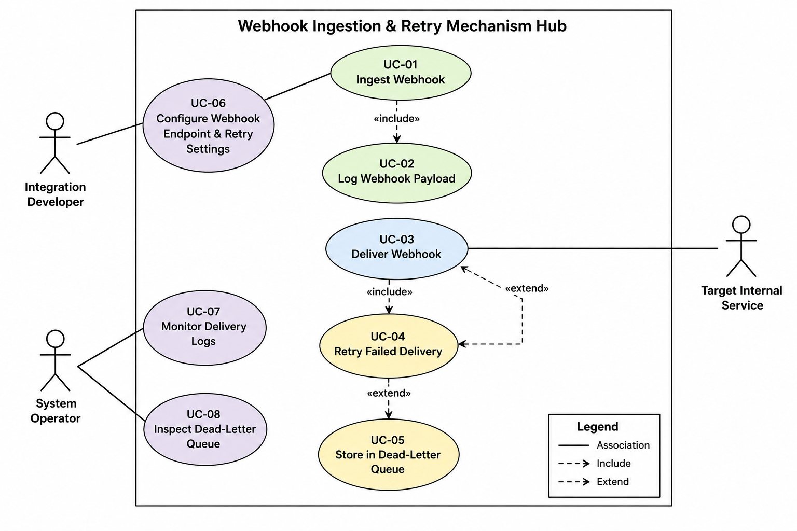

6. Use-Case Flow Specification
Use Case: UC-03 — Deliver Webhook
Primary Actor: Integration Developer / Webhook Gateway

Preconditions
- A valid webhook has been received by the gateway.
- A target endpoint is configured.
- The webhook payload has been logged.

Postconditions
Success:
- Webhook payload is delivered to the target endpoint.
- Delivery status is recorded in the delivery log.

Failure:
- Failed delivery is retried using exponential backoff.
- If all attempts fail, the webhook is stored in the dead-letter queue.

Main Success Scenario
1. The system receives an inbound webhook.
2. The system validates the webhook request.
3. The system logs the webhook payload and associated request information.
4. The system identifies the configured target endpoint.
5. The system forwards the webhook payload to the target endpoint.
6. The target endpoint successfully acknowledges the webhook.
7. The system records the successful delivery in the delivery log.
8. The system completes the use case successfully

Alternate Flow — Delivery Failure
5a.1 The system detects that delivery has failed.
5a.2 The system records the failed delivery in the delivery log.
5a.3 The system waits 1 second before retrying.
5a.4 The system retries the webhook delivery.
5a.5 If delivery fails again, the system waits 2 seconds.
5a.6 The system retries again.
5a.7 The system continues with 4-second and then 8-second backoff intervals.
5a.8 If delivery eventually succeeds, the system records the successful delivery and ends the use case.
5a.9 If all retry attempts fail, the system stores the webhook in the dead-letter queue.
5a.10 The system records the final failure status.

7. Submission Checklist
- Exactly 5 Functional Requirements (FR-001 to FR-005).
- Exactly 2 Non-Functional Requirements (NFR-001 and NFR-002).
- Every requirement contains ID, Type, Description, Priority, Acceptance Criteria, and Rationale.
- UML Use-Case Diagram contains all actors and primary use cases, with at least one «include» and one «extend».
- Use-Case Flow contains Preconditions, Postconditions, Main Success Scenario, and one Alternate Flow.

